

**Team Members**

Angelo Coonghe | 180004566

Sanket Kanji Hirani | 150016252

**Supervisor**

Dr Fadi Fayez

Proposal for Developing a Mobile Application

Hot Topic in Software development

Table of Contents

Chapter 1: Introduction 3

1.1 Background 3

1.2 Current Situation 3

1.3 Scope 3

Chapter 2: Project Charter 4

2.1 Research Question 4

2.2 Aims and Objectives 4

2.3 Project Measurable Organisational Value (MOV) 5

Chapter 3: Literature Review & Requirements Gathering 6

3.1 Application Reviews 6

3.1.1 MIT Student Canvas 6

3.1.2 National American University 7

3.1.3 Studydrive – The Student Platform 8

3.1.4 BRAINYOO Flashcard App 9

3.1.5 StudySmarter - Your learning app for university 10

3.1.6 AUC Mobile 11

3.2 Discussion 12

3.3 Comparison Table 13

3.4 Literature Review Summary 14

Chapter 4: Project Plan and Brief 14

4.1 Requirements Identification and Analysis 14

4.2 Design and Analysis 16

4.3 Risk Analysis and Mitigation 18

4.3.1 Time Constraints 18

4.3.2 Application Development Immaturity 18

4.3.3 Communication Risks 18

4.3.4 Requirements Inflation 19

4.3.5 Technological Failure 19

4.4 Project Methodology 20

4.5 Technologies and Resources Required 21

4.5.1 Android Studio 21

4.5.2 Google Drive 21

4.5.3 Office 365 and Google Docs 21

4.6 Project Schedule 21

4.6.1 Project Approval 22

4.6.2 Project Proposal 22

4.6.3 Application design, development and testing 22

4.6.4 Project report 22

Appendices 23

Appendix A 23

Reference 25

# Work Distribution

|  |  |
| --- | --- |
| Task | Team Member Responsible |
| *Introduction* | *Angelo* |
| *Current situation and scope* | *Angelo* |
| Research question | Sanket |
| Project aims, objectives and measurable organisational value | Sanket |
| *Application reviews (3.1.1 to 3.1.4)* | *Angelo* |
| Application reviews (3.1.5 and 3.1.6) | Sanket |
| *Application comparisons* | *Angelo* |
| *Literature discussion and literature review summary* | *Angelo* |
| *Requirements identification and analysis* | *Angelo* |
| *Application design and analysis* | *Angelo* |
| Risk analysis and mitigation | Sanket |
| Project Methodology | Sanket |
| *Project technologies and resources* | *Angelo* |
| Project Schedule and work breakdown structure | Sanket |
| Report designing and formatting | Sanket |
| References | Angelo and Sanket |

# Chapter 1: Introduction

## 1.1 Background

Being established in 1970, Manukau Institute of Technology is one of the largest , category 1 rated (highest possible education rating rated by the New Zealand Qualifications Authority) educational institutes in New Zealand (New Zealand Qualifications Authority, n.d.). Being a technical, vocational & professional education provider, Manukau Institute of Technology enrols roughly 14,000 students every year (Manukau Institute of Technology, 2018). Being an educational provider with high number of students, the institute has student’s portal & all other web-based tools to help the students (Student Life, n.d) but not an application. In the fast-moving world where everyone is getting most of their day to day tasks done on the go, being able to access resources on the go (mobile) is a mandatory requirement. This is where our idea of a Student Hub, an android mobile application to help students with their requirements and resource/knowledge sharing comes in.

## 1.2 Current Situation

Although there is a web-based communication medium available as mentioned above, not many students will find it very useful as most of the students who study at the institute are working part time having a busy life. So, being active in a medium where you need to log-in using a computer and searching and learning is a task that is comparatively difficult than using a mobile app which can be accessed in just a swipe of a finger. By making a mobile application for the Manukau Institute of Technology students, it makes their knowledge sharing and learning process quick and effortless encouraging students to communicate with other students who can help improve their knowledge or help with exams.

## 1.3 Scope

Although the application can be developed for everyone at the institute that may include students, lecturers and staff, our focus on this project will only be students. Rather than setting a bigger scope with a short timeframe to complete the project, we have decided to limit the application registration and use only to the institute’s students, in other words for a user with “@manukaumail.com” email address. And we will only be developing an application for the Android operating system, leaving iOS & Windows for future development plans. Initially, we will be limiting our application to provide categories of only main educational categories provided by the institute such as Business, Digital Technologies, Tourism & etc (Manukau Institute of Technology, Areas of Study, n.d.). There will be no other categories other than study streams but for the future development plans, the application is expected to expand to other non-study categories such as RideShare and FlatMates.

And the Application will be called ‘MIT Hub’.

# Chapter 2: Project Charter

## 2.1 Research Question

A question that casually pops up when you analyse the current situation at Manukau Institute of Technology is that, “Is there an opportunity to facilitate better interaction and communication on the go for the Manukau Institute of Technology community?”. Yes, there is an opportunity, and this is where our project comes into play. With carefully thought out aims and objectives that cooperate with the mission and goals of Manukau Institute of Technology, this project can help resolve this question.

## 2.2 Aims and Objectives

Currently, the Manukau Institute of Technology students have a limitation in terms of sharing study related thoughts, ideas and resources with other fellow students. The institute does offer canvas that acts as the main hub for accessing any course related resources, however this is optimized for desktop and laptop use. It is also limited in terms of the communication capabilities such that any contributions to course discussions and blogs are restricted only to the current students enrolled to that course.

With this project, the main aim is to facilitate the students of Manukau Institute of Technology with better communication and interaction within the institute’s environment and enhance their student experience. The main objectives of the project are outlined below:

* Provide a mobile platform that allows students to share their knowledge, ideas or even ask for study advice or help from other students. This is going to be achieved by creating a mobile application that will allow any student of the institute to post a discussion topic or study question as well as having the ability to respond to any other discussions that have been posted by other students.
* Research on different features that can be added to the application to make it as user-friendly as possible while keeping all interactions and discussions smooth and effective. This will be done by comparing other similar mobile applications and selecting the features that will best suit our application.
* And finally develop an application based on our research findings.

## 2.3 Project Measurable Organisational Value (MOV)

The Measurable Organisational Value (MOV) of this project put in simple terms is the value that this project will provide for Manukau Institute of Technology and for this project to be valuable to the institute, this project’s measurable organisational values must cooperate with the goals and mission of the organisation (Alexandra, 2018).

### 2.3.1 Desired Area of Impact

Customers (students) – the goals of Manukau Institute of Technology are centred around improving student experience and satisfaction as well as their performance (Manukau Institute of Technology, Plans and Strategies, 2018). Our project will help improve student experience as access to resources, sharing ideas, seeking help and communicating with other students becomes easier and more convenient.

Strategic – the vision of Manukau Institute of Technology is to be recognised as the leading institute of technology in New Zealand (Manukau Institute of Technology, Plans and Strategies, 2018). Having a mobile application fits well with their vision as, in this modern era (the world of smartphones), everyone one wants the convenience of having access to everything at the tips of their fingers.

### 2.3.2 MOV Metrics

With the deployment of the MIT Hub application, Manukau Institute of Technology should receive a 15% - 20% increase in the number of positive reviews they receive from their student satisfaction surveys within one year.

In addition to that, the sharing of knowledge, better access to study resources and the increased interactions between the students is estimated to improve learning possibilities with an expected increase of students’ A grading by 10% in the next year.

# Chapter 3: Literature Review & Requirements Gathering

As we will be developing an Android application, in the literature review, we will be reviewing the current system in use at Manukau Institute of Technology and then investigate similar applications that are available on the Google Play Store.

## 3.1 Application Reviews

### 3.1.1 MIT Student Canvas

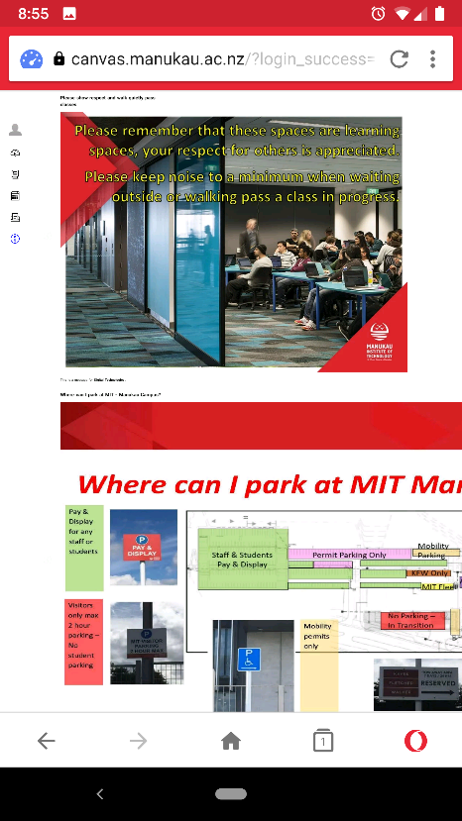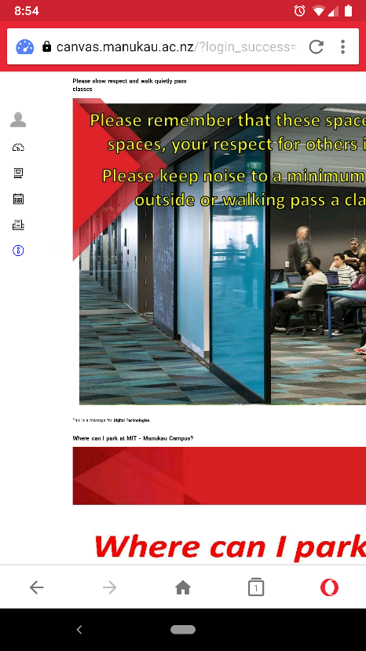

The current system at Manukau Institute of Technology is Canvas, where all the students can have discussions with the class they have enrolled to. This is a limitation of knowledge sharing where students cannot communicate outside their classroom. And as you can see in the screenshots above, when loading the canvas on mobile, it only displays half of the actual content as it is not very well optimized for mobile viewing and specially made for desktops. And, the loading time of the website is high due to the reason its focused mainly for desktops/laptops and not mobile phones.

Most of the notifications of discussions are sent through email which again is a long process to read, and then log-in to canvas and check the reply from fellow students. So, students need a better solution than a web canvas that is already in use at the institute and that is where MIT Hub comes in.

Now, we will be looking at different Android Applications that are similar to our idea of MIT Hub to get some ideas of functionalities and so on.

### 3.1.2 National American University

*by National American University* (National American University, 2018)

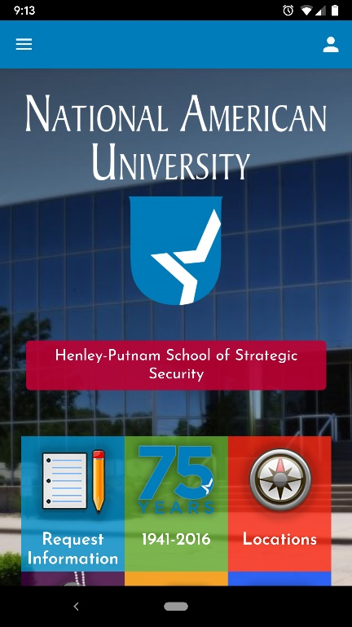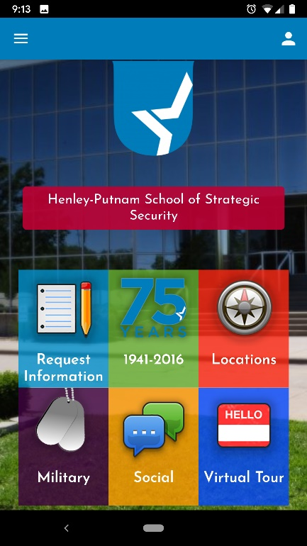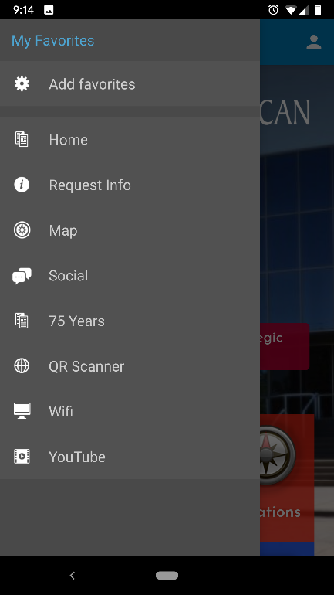

This application is developed for National American University with the purpose of students managing their account while getting more information about the university, facilities and following the social feeds of the university itself. The application does not offer any communication platform for students to share or discussions.

Although the design is simple and intuitive, it is not up to date with the current trend of material design. Navigation is on the good side and bad as the application has both side navigation on left and right along with middle tiles.

The application is mainly designed to communicate one-way information, from the University to students. But integration of 3rd party features like YouTube & QR code is beneficial for students.

### 3.1.3 Studydrive – The Student Platform

*by Studydrive GmbH* (Studydrive GmbH, 2019)

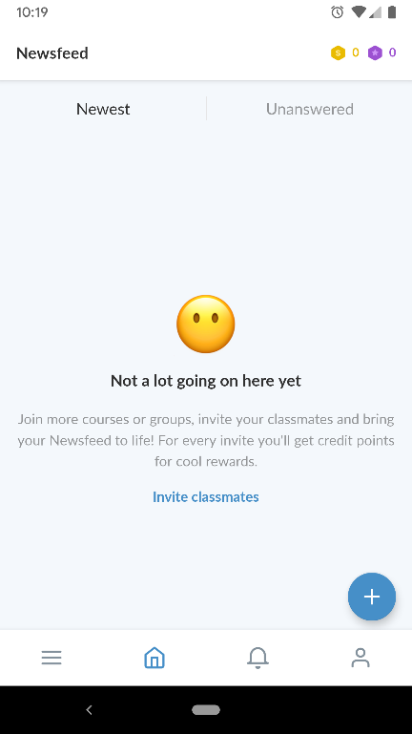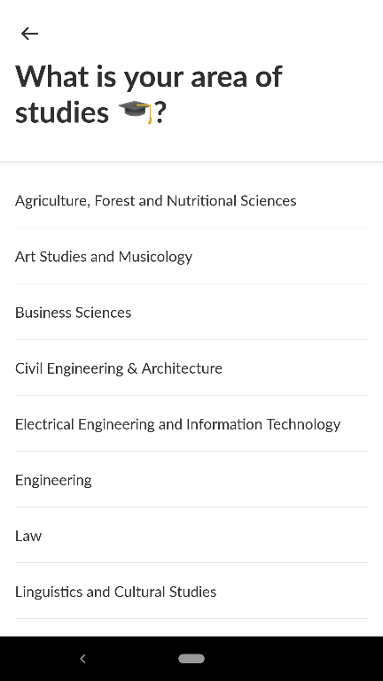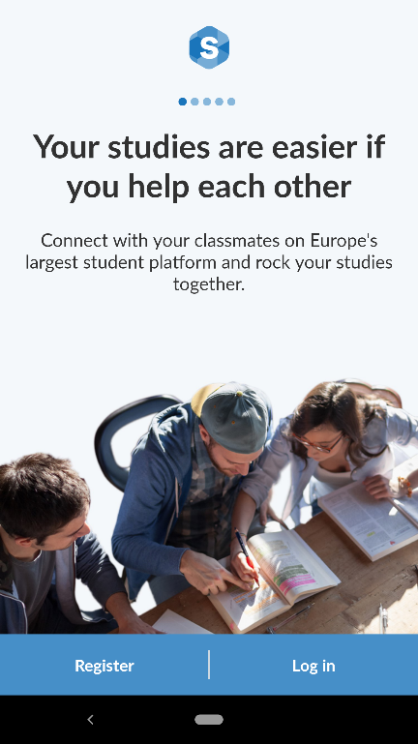

This application is an example of one of the best applications available on the Google Play Store. The design is very clean and exceptionally well thought out for students to make navigation simple with swipe gestures. Also, the interface is very clean and minimalistic which goes very easy on eyes to use the application for a long time effortlessly.

When it comes to functionality, the application is equally great with its design where the functionality is seamless with offering only what is required. And, the selection of categories when it comes to study modules and courses are good in terms of numbers. Also, the functionality of inviting friends is a great way to increase more downloads of the application itself.

Although this application is not focused to one specific university or institute, the ideas we can get from this is very useful and can be integrated into our idea. Most of the features and functionalities can be directly transferred across/adopted to our application.

### 3.1.4 BRAINYOO Flashcard App

*by Brainyoo Mobile Learning GmbH* (Brainyoo Mobile Learning GmbH, 2019)

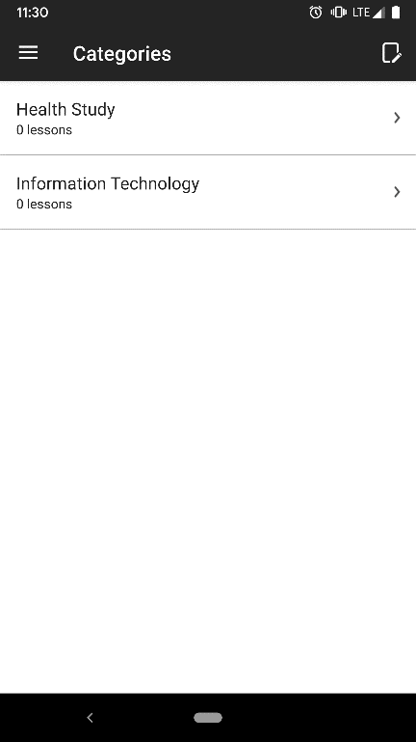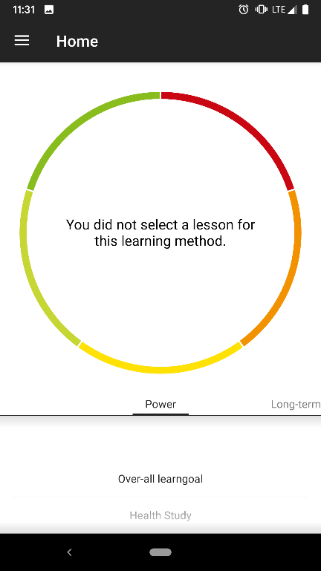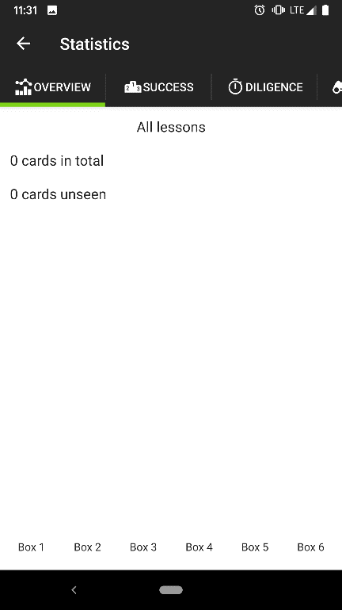

This is another great application available on the Google Play Store which helps students with their learning. The application itself is great but is heavily focused on self-learning rather than a group environment or knowledge sharing.

The design of this application is a great advantage being very simple and intuitive at the same with simple visual designs that makes the users interested in using the application without issues.

But when it comes to functionality, there is more to the application than what it looks. Specially with reports that offer how your learning process with the application. Also, the application’s functionality of demo that allows users to use the application to get a feel of it without even registering is a great advantage that will encourage users to like it even before they register and become actual users.

But it takes bit of timing figuring out the application as the navigation seems to be bit tricky and needs bit of training on how to use it for the first-time users.

### 3.1.5 StudySmarter - Your learning app for university

by StudySmarter (StudySmarter, 2019)

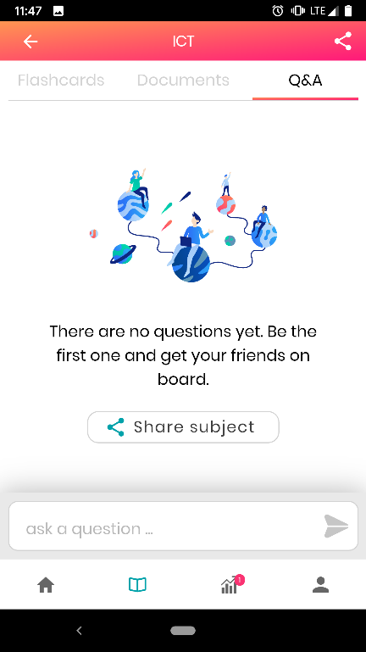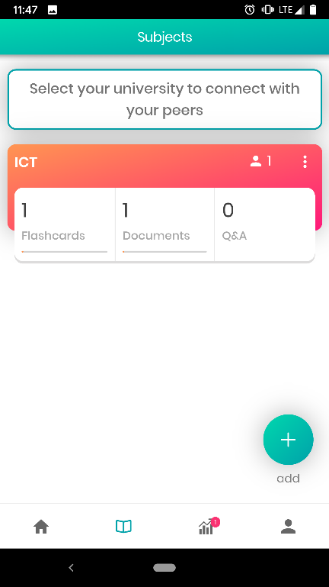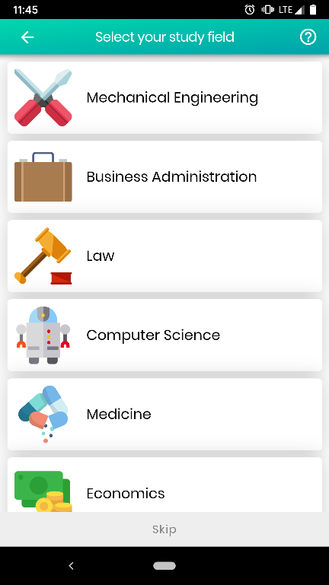

This is a well-designed application that maintains the current standards of industry designs. The application is more focused on the general society than to a specific institute or university therefore the features offered are much more generic.

The colour choice of the application is great at the same time being simple and therefore appealing to the users. Also, it has got a great cards’ design that makes it easy for users to navigate but still maintaining the simple and professional looking design.

The functionalities of the application match up to its design standards where the application offers a cloud for saving documents and image addition too, a unique feature that is not provided by the other similar applications. The application also offers share features which encourages social interaction between students.

### 3.1.6 AUC Mobile

*by The American University in Cairo* (The American University in Cairo, 2019)

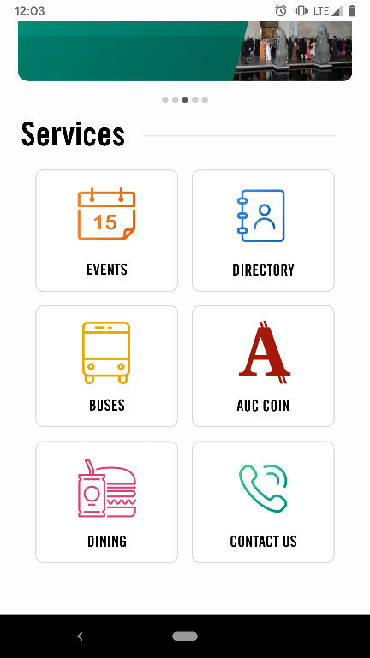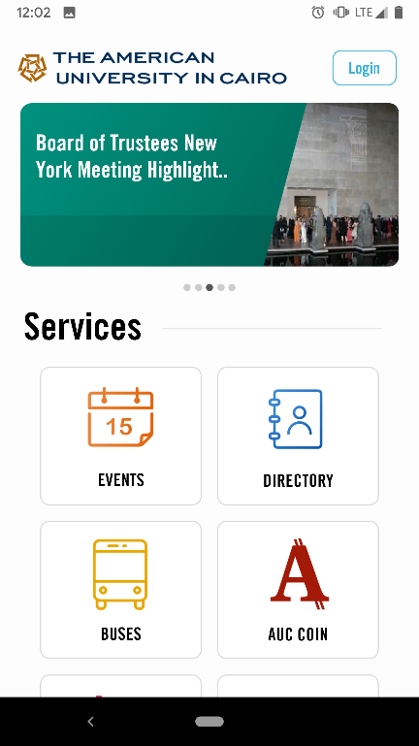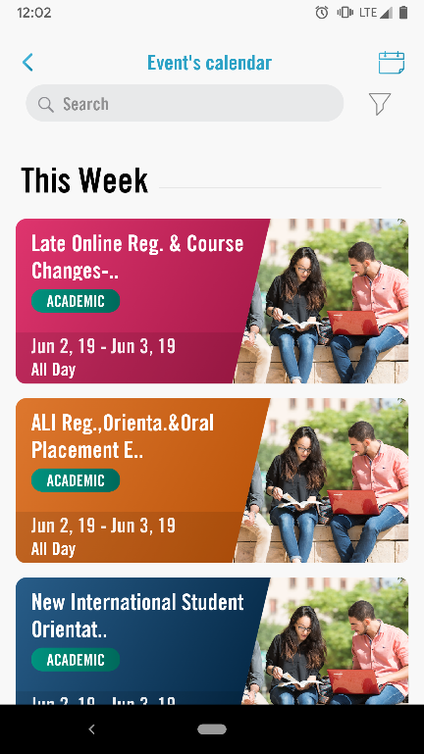

The final application we experienced is one that was published and is being used by an American university which is also focused mainly towards one-way communication where the application’s main goal is the university providing information and help to their students and no options for students to communicate back using the application.

The functionalities of the application are good, but the scope is very wide where it provides information from travelling, dining and much more. While the functionalities are specific to the university itself which is great, the effectiveness of using this application by students over widely used and more established travel applications is doubtful.

The application itself is very well and beautifully designed and very easy to use, providing access to guest users to get an idea of how it works even before registering.

## 3.2 Discussion

After reviewing the current system in place at MIT for students for knowledge sharing and communication which is Canvas and all the above applications that we reviewed, we have learnt that;

1. The current system at Manukau Institute of Technology is not as effective as having a mobile application that will be handy to use on the go.
2. While the current system offers most of the functionalities it is not mobile friendly or portable for students to stay in touch all the time which limits the use of this system.
3. There are few applications that excel in design and some in functionalities which we can adopt and integrate into our application which we believe will be highly useful for students – these functionalities might not be incorporated straight-away and could be in a future development plan for the application.
4. We also learnt that while keeping the design simple and clean the functionalities are what makes the application great when it comes to real-life use.

All the above applications are targeted for 3+ audience except one but this is mainly because these applications are educational thus making it safe for all users. While some applications have exceptionally great review and ratings, others lack in that and it could be because of the age of the applications and numbers users its focused on. If the applications are international like BRAINYOO & StudySMARTER, then the reach of the users are very high thus giving a great expose to application which will increase the reviews and ratings. But the applications with lower ratings and reviews are mainly developed for specific institution thus the users are limited but this is not to say the applications need a lot of improvements.

## 3.3 Comparison Table

|  |  |  |  |  |  |
| --- | --- | --- | --- | --- | --- |
| Application Name | National American University | Studydrive – The Student Platform | BRAINYOO Flashcard Application | StudySmarter - Your learning application for university | AUC Mobile |
| Developer | National American University | Studydrive GmbH | Brainyoo Mobile Learning GmbH | StudySmarter | The American University in Cairo |
| Target Age | 3+ | 12+ | 3+ | 3+ | 3+ |
| Rating | 3.6 | 4.5 | 4.3 | 4.2 | 4.3 |
| No. of Reviews | 19 | 259 | 2,590 | 156 | 16 |
| Downloads | 1,000+ | 10,000+ | 100,000+ | 50,000+ | 1,000+ |
| Design Trend | Semi Tiles | Material Design | Open Plain Design with graphs | Cards & Semi material | Tiles Design |
| Application Category | Education | Education | Education | Education | Education |

## 3.4 Literature Review Summary

|  |  |  |
| --- | --- | --- |
| Application Name | What’s Good? | What’s Bad? |
| National American University | 1. Simple & Intuitive 2. The functionality is relevant to university | 1. One-way communication focused. 2. Design is out of trend. |
| Studydrive – The Student Platform | 1. Clean & Simple Design 2. Functionality is exceptionally good 3. Easy to Navigate | 1. Not specific to one Institute or University |
| BRAINYOO Flashcard App | 1. Great design that is very simple | 1. Self-study centric application 2. Navigation is slightly complex |
| StudySmarter - Your learning app for university | 1. Exceptionally well-designed application 2. The functionalities are great | 1. Functionalities are too general |
| AUC Mobile | 1. Simple to use 2. Design is user friendly | 1. Offer too many categories 2. Focused on one-way communication |

# Chapter 4: Project Plan and Brief

## 4.1 Requirements Identification and Analysis

As this is a brand-new application that we will be developing for Manukau Institute of Technology, we will gather the ideas from the applications reviewed above in the ‘Literature Review’ Section. Also, we learnt all the possible categories from the institute website and Canvas along with other resources based on which our categories on the application will be showcased. During the development, we will be needing a database of some sort to integrate into the application to store student details when they register, as we do not have access to the current database used by Manukau Institute of technology to store their students’ data

To start with, we have drafted a design that will be our home page with categories that we think will be widely used on this application. For this, we use the trend of students register in New Zealand for specific streams of courses.

But all other categories will be based on the institute’s website where we have gathered all the categories of streams offered by Manukau Institute of Technology so the application can be limited only for those – at least for now.

To make the application easier for students to use, we will be using a clean and simple design that will be a material design to keep up with the current trend of mobile applications. Also, we will use very light colours which we learnt from the ‘Literature Review’ above that will be easy on students’ eyes as they need to be able to use mobile screens without having eye strains.

Another aspect of this application will be the navigation. This must be very simple, and students should be able to use it as soon as they register. So, we will be using simple navigational techniques such as swipe gesture which is also a current trend while also providing for an easy navigational design and feel to the application. However, we will focus on not having the application very cluttered with too many navigation options like the ‘National American University’ mobile application.

We will be drafting our designs based on our learning above and then analyse the features that will be suitable for development. Based on those results, we will then go ahead or make changes to the draft.

When it comes to functionalities, we will be limiting the application’s functionalities to only study categories for this project although we plan to expand it so other categories, outside studies also can be available. These categories may include RideSharing, FlatMates & so on.

As per our scope statement above, we will be limiting the application to only Android and there will not be an application for iOS or Windows OS although we might look into it in the future.

For students to be able to search, we will be creating a landing website with Google Indexing so it will make it easy when it comes to finding the application on the web.

## 4.2 Design and Analysis

We have discussed the designs based on our literature review, requirements gathering and analysis where a best possible option can be provided in our application and came-up with the initial draft designs.

Please note our designs provided here are only initial design drafts and subject to change based on development;

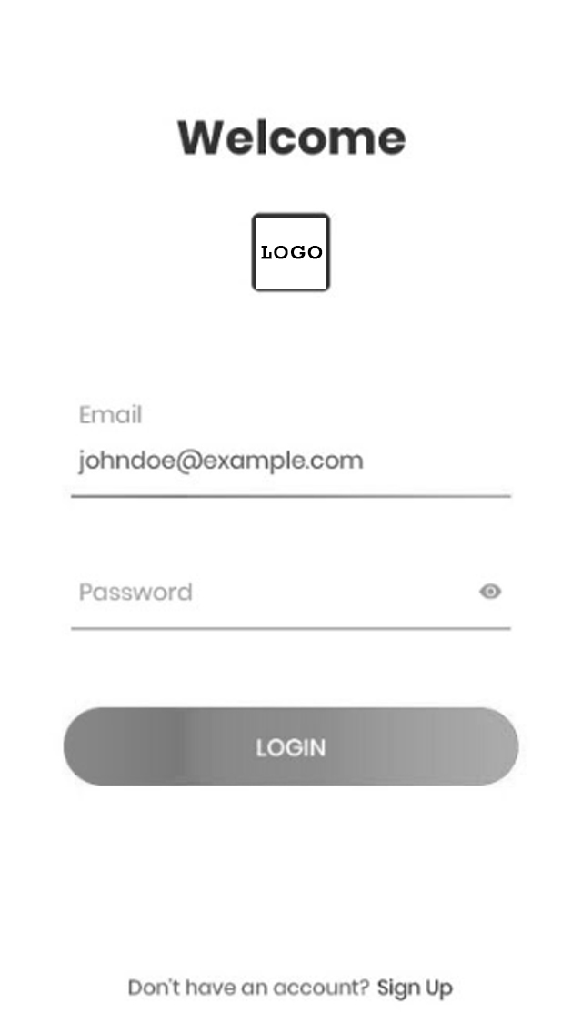

**Initial Screen for Users**

This is to keep the screen clean, simple and elegant; we chose to provide minimalistic design based on the ideas we took from other applications. Also, at this point we are not focused on any colours and provided the draft as a black and white draft image, but we are planning to use the same colour theme as the Manukau institute of Technology website, so the students quickly recognize the application as one of the institute’s. The purpose of this screen is simple as any log-in screen, Register and Log-in.

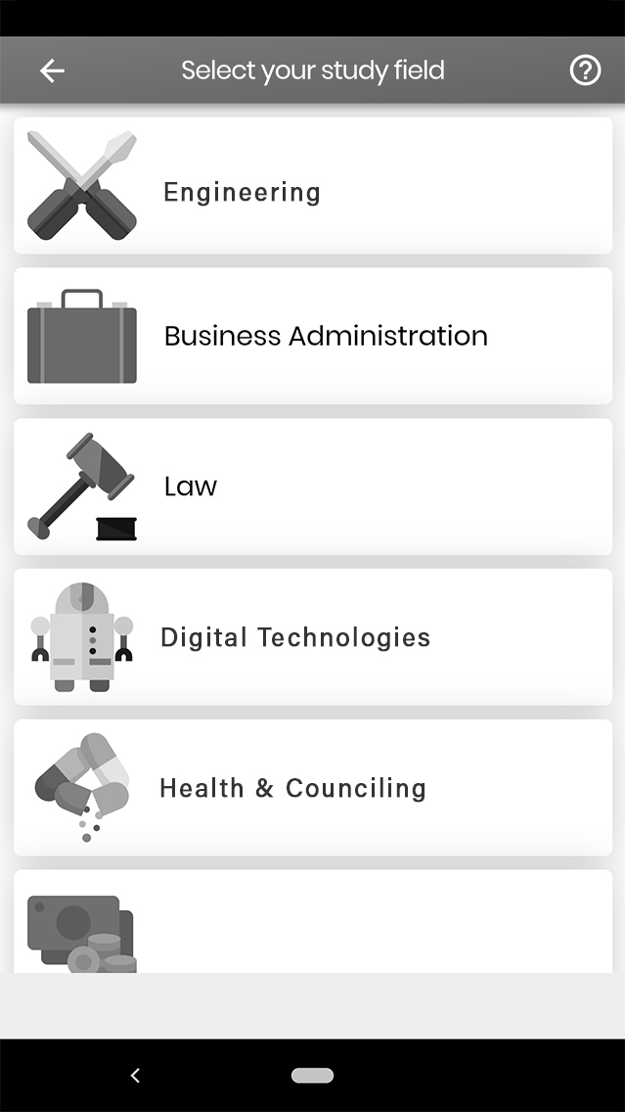

**2nd Screen**

This will be main screen or Home Page after sign-in for students where they can choose their category of study to join the conversation. Based on our development, we might look into loading the chosen category for registered users as default and then have an option to change category rather than having to choose category every single time. This will reduce one action for users to find what they are after.

And the other designs will follow similar material design as we go on developing the application. By doing this, we will be able to keep up with the design trend in the industry and provide the students with a simple and intuitive mobile application that looks professional and easy to use.

## 4.3 Risk Analysis and Mitigation

Uncertainties are always part of a project be it a large complex project or just a small simple one. Identifying these uncertainties early on and coming up with a well thought out plan to minimize the effects of these risks and possibly avoiding them can be the difference between the project succeeding or failing. Some of the risks associated with our project are outlined below:

### Time Constraints

We have been given just eight weeks to complete the project. This is very limited considering the amount of work that needs to be done to achieve the goals of our project. For this reason, we have identified and clearly defined a narrow scope for the project to ensure that all major targets are met. A detailed Gantt chart with a breakdown of the tasks has also been designed to track our progress and ensure that all the tasks are completed on time.

### Application Development Immaturity

Angelo is a member of the project team who is a networking student while I (Sanket) am just a student studying software development. This means that we lack the proper expertise to develop an application of a very high standard. In addition to that, it is even more likely that we will face major obstacles when developing the application. To manage the lack of experience, we will have to spend a lot of time researching to make sure that we make the right decisions and platform selections for our project as well frequently consulting with our lectures and any of our friends who have a better understanding and experience in the world of software development.

### Communication Risks

Communication plays a key role in every project and this project is no different. Since both Angelo and I (Sanket) have different backgrounds in terms of study fields and where we come from it is highly likely that we will be having different views and approaches to solving problems and working on any project task. This can sometimes lead to unnecessary confusion and conflicts which might delay our work on the project or even possibly cause the project to fail as we would be on different wavelengths. In order to stop this from happening, we will be holding regular team meeting as well as communicating as often as possible to clear up any confusions or misunderstandings.

### Requirements Inflation

This project requires a good amount of research to be done before starting to design and write the code for the application. This might lead to an increase in the number of ideas and functionalities that we could add to the application and. This is a very huge risk for the project as we have a strict timeframe and just two students working on the project meaning limited resources. Adding more and more functionalities to the application will surely make it better and more appealing, however this requires extra time that we cannot afford. One way of minimizing this risk is to stick to the scope we had identified earlier and get the main basic functionalities of our application working first. This will ensure that the project is completed on time and possibly if the general feel of the application is good, we can gradually introduce other features and constantly make improvements to the application.

### Technological Failure

Technological or hardware failures are not very likely to occur but there is a slight chance that a hardware or technological component would fail for example a storage device failing, laptop being stolen or even losing your internet connection. Any of these unfortunate events would lead to loss of project work and cause unnecessary delays. Backups are very important in this case, and an added precaution of both members having at least one copy of any project related document can negate this risk.

The table below summarises the risks and mitigation analysis done above:

|  |  |  |  |
| --- | --- | --- | --- |
| Risk | Probability Level | Threat Level | Mitigation |
| Scheduling Risk | High | High | * Have a limited scope * Create a detailed Gantt chart to plan and schedule our project and sticking to that plan |
| Application Development Immaturity | High | Very High | * Seeking for assistance from the lectures and other experienced developers * Doing lots of research |
| Communication Risks | Medium | Low | * Holding face to face team meetings as often as possible * Documenting all the discussions and tasks allocated during team meetings |
| Requirements Inflation | Medium | High | * Stick to the scope of the project * Get the main and basic functionalities of the application working first before adding any flair to the application |
| Technological Failure | Low | High | * Backing up all project related work on the cloud * Making sure all individual work is shared to ensure that at least one team member has a copy in case of a technological fault |

## 4.4 Project Methodology

The software methodology that we will use in our project is the waterfall model. This does raise a few eyebrows in the current world of software development where the agile and more iterative methods are preferred due to their rapid growth and proven track record (Harvey, 2012). These methods are more suitable for projects that have a reasonable amount of time and budget and where there is a huge amount of customer involvement.

So why is the waterfall method more suitable for our project? Our project is very limited in terms of the amount of time we have (8 weeks) as well as a large amount of emphasis that is put on the research part of the project making us spend the majority of the project time identifying and selecting the requirements, documenting our research and planning for the development of the application. This implies that our project is heavily plan driven and with the addition of having all the tasks being time specific it makes the waterfall model that much more suitable for our project (Zulqadar, 2019).

Another reason why we decided to go with the waterfall model is because our project is not large enough to suit the other more complex software methodologies.

## 4.5 Technologies and Resources Required

### 4.5.1 Android Studio

Android studio is going to be a vital resource for the project. It is the official integrated development environment especially designed for the development of android applications (Wikipedia, Android Studio , 2019) and one that the project’s developer is familiar with, thus being the best choice of IDE (integrated development environment) for this project. Adding on to that, the major objective of this project is to develop an android application, highlighting the need of this technology.

Android studio does support a variety of different software programming languages, Java being the preferred option for this project.

### 4.5.2 Google Drive

Google drive is another major resource that will help organise, share and store any project documents. A shared folder has been created for this project and this is where all project resources such as the proposal report, teem meetings and presentations will be stored to ensure that both members of the project have access to these resources at all times as well as make contributions in real time. Another reason for the use of Google drive is to act as a backup for the documents to ensure that no work is lost in the case of an unexpected failure.

### 4.5.3 Office 365 and Google Docs

Google Docs is a very nice feature to have utilised in this project as this allows both members to work on one document at the same time. However, there is a limitation in terms of the designing and other features offered and this is where the Office 365 applications such as MS Word and MS PowerPoint will assist the project leader make the additional and final changes to these documents to make them more presentable, professional and appealing.

## 4.6 Project Schedule

Project scheduling plays a very important role in every project. Time constraints has been identified as a major risk and therefore the tasks of the project have been carefully planned to ensure that every task is given enough time and to make sure that the project is completed on time. The major tasks of the project are outlined below:

### 4.6.1 Project Approval

The breakdown of this major task is; formation of the team, brainstorming to come up with a project idea, sharing the project idea with our project supervisor and finalising the project idea.

### 4.6.2 Project Proposal

The subtasks include the process of project scheduling, identifying project objectives and goals, recognising project risks and how to avoid them, performing the literature review and finally documenting the project proposal.

### 4.6.3 Application design, development and testing

This is the point where the software methodology is integrated into the project and this is where the making of the application begins.

### 4.6.4 Project report

Creation of the final report that provides an insight of all the work done in this project.

Please refer to the Gantt chart in Appendix A for a more detailed version of the project schedule (major project milestones and a breakdown of all tasks within the project and the time frames in which they must be completed).

## 4.7 Work Breakdown Structure

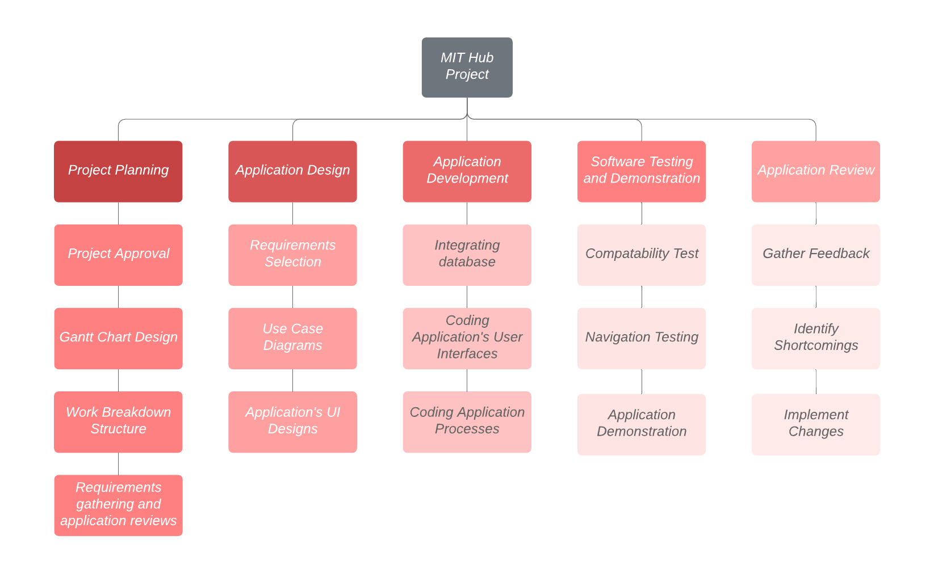Work breakdown structure is a key component in the planning and scheduling of a project. It helps breakdown the total scope of work to be done into smaller tasks, making the project more organised and manageable (Wikipedia, Work breakdown structure, 2019).

# Conclusion

This report has analysed the current situation at Manukau Institute of Technology and discovered an opportunity in the shape of an android application that could possibly make the life of students easier by making communication and resource and knowledge sharing easier and more convenient. However, we have identified numerous risks that could cause the project to fail but at the same time come up with ways to minimize their effects.

# Appendices

## Appendix A

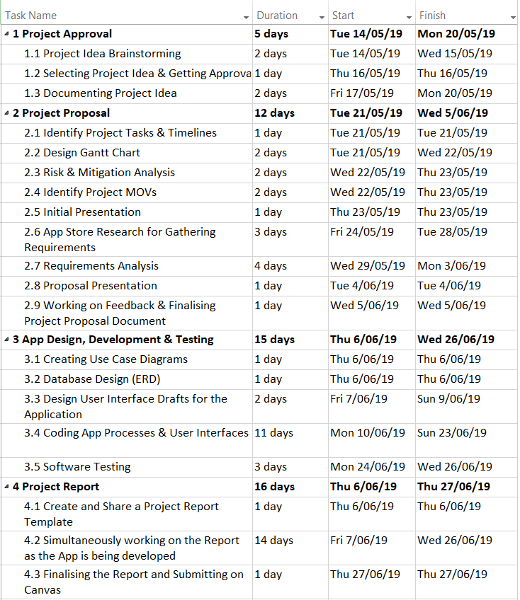

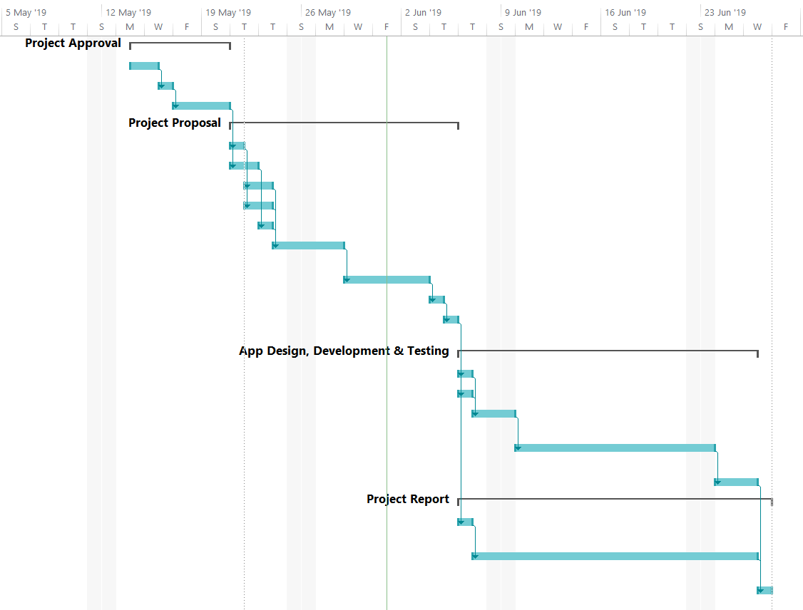

# References

Alexandra, J. (2018, February 09). *Measurable Organizational Value*. Retrieved from Binus University School of information Systems: https://sis.binus.ac.id/2018/02/09/measurable-organizational-value-mov/

Brainyoo Mobile Learning GmbH. (2019, May 13). BRAINYOO Flashcard App (2.8.7) [Mobile Application Software]. *BRAINYOO Flashcard App*. Retrieved May 30, 2019, from https://play.google.com/store/apps/details?id=com.brainyoo.brainyoo2

Harvey, R. (2012, March 9). *Is the Waterfall software development methodology still viable?* Retrieved from Stack Exchange: https://softwareengineering.stackexchange.com/questions/139013/is-the-waterfall-software-development-methodology-still-viable

Manukau Institute of Technology. (2018). *Manukau Institute of Technology Annual Report 2018.* Manukau Institute of Technology, Auckland. Retrieved May 29, 2019, from https://www.manukau.ac.nz/__data/assets/pdf_file/0011/427295/MIT-2018-Annual-Report.pdf

Manukau Institute of Technology. (2018). *Plans and Strategies*. Retrieved May 30, 2019, from Manukau Institute of Technology Website: https://www.manukau.ac.nz/about/about-the-institute/plans-and-strategies

Manukau Institute of Technology. (n.d.). *Areas of Study*. Retrieved May 29, 2019, from Manukau Institute of Technology Website: https://www.manukau.ac.nz/study/areas-of-study

Manukau Institute of Technology. (n.d.). *Student Life*. Retrieved May 29, 2019, from Manukau Institute of Technology website: https://www.manukau.ac.nz/student-life

National American University. (2018, August 9). National American University (1.2) [Mobile Application Software]. *National American University*. Retrieved May 30, 2019, from https://play.google.com/store/apps/details?id=edu.national.dist

New Zealand Qualifications Authority. (n.d.). *Manukau Institute of Technology provider details*. Retrieved May 29, 2019, from NZQA Website: https://www.nzqa.govt.nz/providers/details.do?providerId=601047001

Studydrive GmbH. (2019, May 14). Studydrive GmbH (2.76) [Mobile Application Software]. *Studydrive GmbH*. Retrieved May 30, 2019, from https://play.google.com/store/apps/details?id=de.veedapp.veed&hl=en_US

StudySmarter. (2019, May 23). StudySmarter - Your learning app for university (1.2.0) [Mobile Application Software]. *StudySmarter - Your learning app for university*. Retrieved May 30, 2019, from https://play.google.com/store/apps/details?id=com.studysmarter

The American University in Cairo. (2019, May 23). AUC Mobile (1.3.1) [Mobile Application Software]. *AUC Mobile*. Retrieved May 30, 2019, from https://play.google.com/store/apps/details?id=auc.edu

Wikipedia. (2019, May 28). *Android Studio* . Retrieved from Wikipedia, the free encyclopedia: https://en.wikipedia.org/wiki/Android_Studio

Wikipedia. (2019, April 2). *Work breakdown structure*. Retrieved from Wikipedia, the free encyclopedia: https://en.wikipedia.org/wiki/Work_breakdown_structure

Zulqadar, A. (2019, February 12). *SDLC Waterfall Model*. Retrieved from Rezaid Web Site: https://rezaid.co.uk/sdlc-waterfall-model/